**Lesson02 Azure App Service Plan**

**Notes: -**

**1-when you create azure app service, you have to create azure plan app service to link together to detect how much paid per month**

https://azure.microsoft.com/en-us/pricing/details/app-service/windows/

**2-we see that we have multiple types of Azure App Service Plans**

**Free, shared: is resources that comes with shared infrastructure so there is limitations on running minutes every day**

**(Free 🡪 60 Minutes and after that it will stop)**

**(Shared 🡪 240 Minutes and after that it will stop)**

**Basic & above 🡪 its real infrastructure owned for you so there is unlimited time consume but the instance (no of VM) is different on each version**

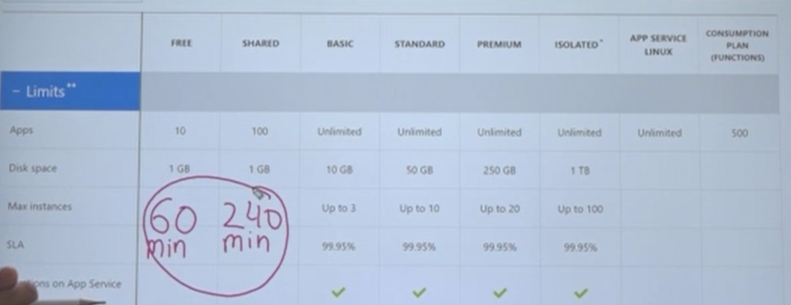

**We see that deployment slots is only available on the standard plan and above**

**We see if you want to apply docker container , you have to go to App service Linux Plan**

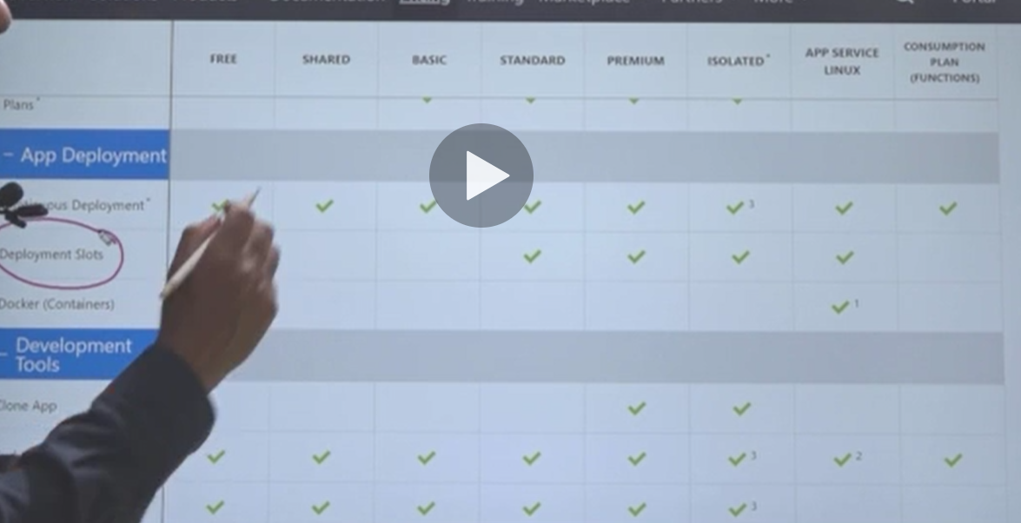

**Hybrid connection: used to connect promise network to Azure Network (available for all)**

**VNET connection: used to connect Azure Web App with Azure VNET**

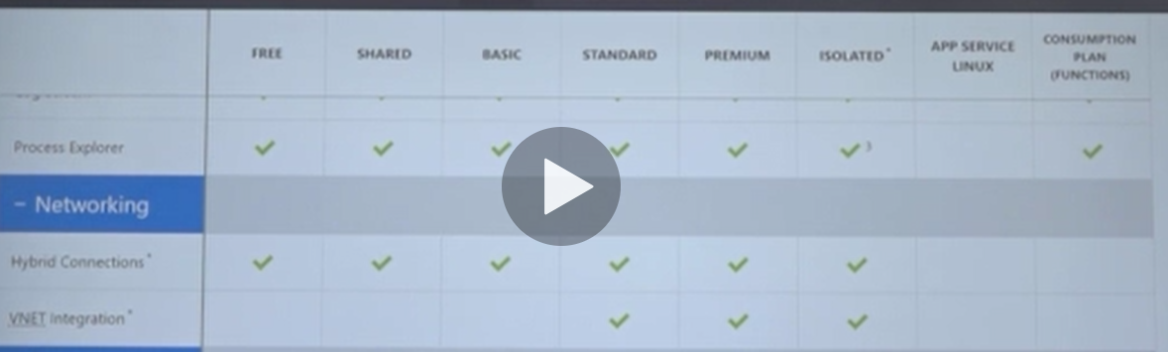

**You can apply multiple kinds of applications as below**

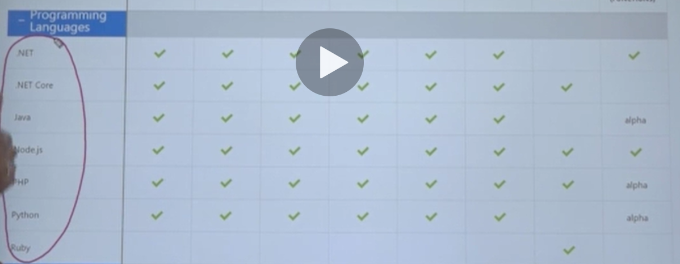

You can apply Auto Scale for standard and above

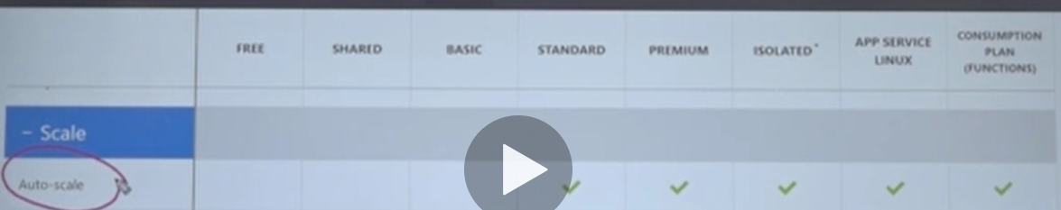

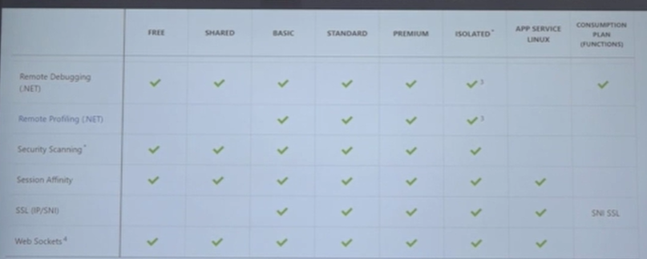

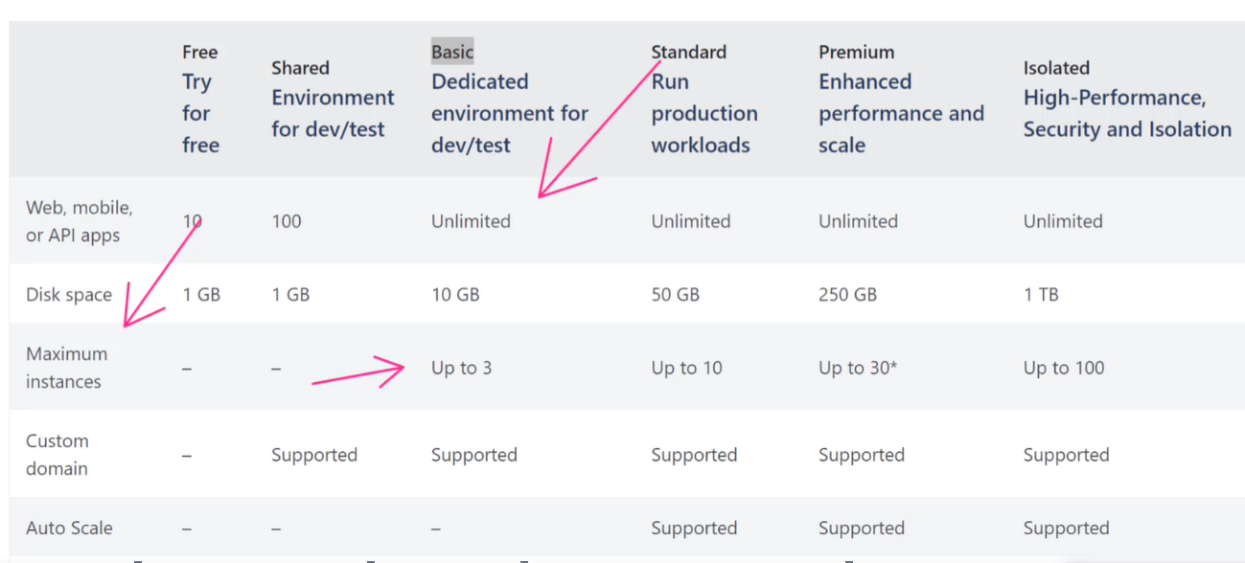

**We can create multiple azure web app services like basic platform create to 3 instances**

**(Means this azure app service plan can hold at maximum 3 azure web app services)**